ZDR Arc algorithm Installation Instructions

1. Download the Github repository (<https://github.com/mwilson14/ZDR_Automated>) and extract the files from the zipped folder into the directory you plan on running the program in.
2. Create a directory called “Machine_Learning” in the directory created from unzipping the folder.
3. The next several steps involve creating a conda environment to run the algorithm in. To create this environment, launch the Anaconda command prompt (on Windows) or a terminal window (in Linux) and type “conda create –name ZDR_ARC” (you can replace ZDR_ARC with a different name you want to call the environment). Make sure you’ve got Anaconda installed first.
4. Activate your new environment with “conda activate ZDR_ARC”
5. Next, we’re going to install the modules we need to run the algorithm in this environment. The commands that follow each install a module we’ll need.
6. Enter “conda install jupyter” This installs jupyter notebooks, which we can use to run the algorithm later.
7. Enter “conda install -c conda-forge arm_pyart” This brings in Pyart, which will be used to read and work with the radar data.
8. Enter “conda install -c conda-forge metpy”
9. Enter “conda install scikit-learn”
10. Enter “conda install -c conda-forge siphon”
11. Enter “pip install nexradaws”
12. Enter “conda install numba”
13. Enter “conda install scikit-image”
14. Open another terminal and activate the ZDR_ARC environment. Navigate to the directory that the algorithm is in.
15. Type “python auto_gui_test.py”. A window should pop up. Enter the radar site you’re interested in running the algorithm for in the window and press the “run realtime” button.
16. The window will probably freeze (this is normal), but you should see output begin to scroll through the terminal. After a minute or so, you should have a .png image in the Machine_Learning directory and a placefile in the algorithm directory as output for the first radar scan. The algorithm will continue updating the placefile and producing more .png images as additional radar scans come in.

Running real-time or archived cases with the GUI

1. Open another terminal and activate the ZDR_ARC environment. Navigate to the directory that the algorithm is in.
2. Type “python gui_test.py”. This window should pop up: 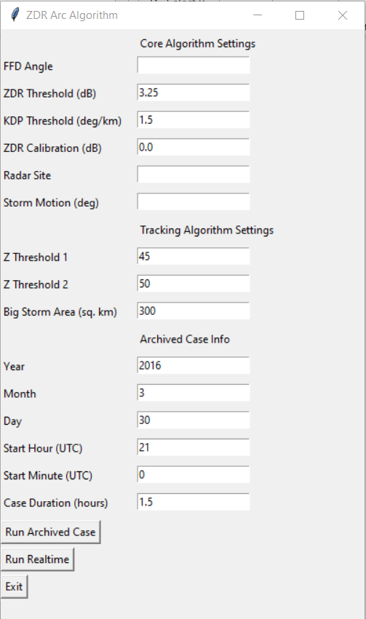
3. To run a realtime case, open GR2 analyst and find the supercell you’re interested in looking at. Draw a vector across the FFD perpendicular to the edge of the reflectivity gradient (you can use the marker tool for this if you put a marker in the core and move the mouse across the gradient to get the direction, as shown below) Enter the direction of this vector in the FFD angle box. If storms are not yet present, the FFD angle can often be estimated by subtracting ~90 degrees from the direction of the sfc-8km bulk shear vector.

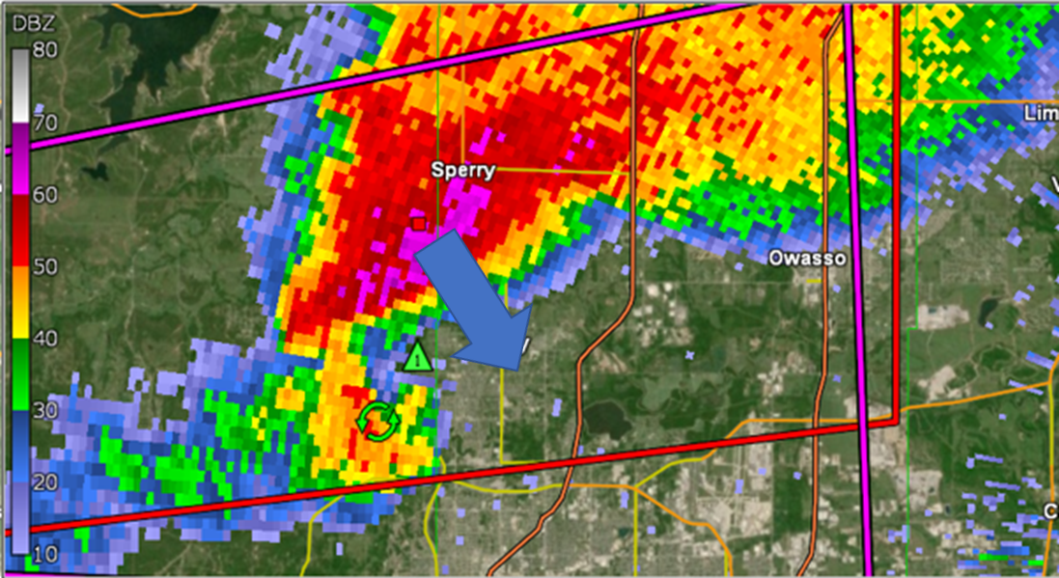

1. Enter the radar site and storm motion in their respective boxes.
2. Hit the “run realtime” button.
3. The GUI will probably freeze or say “not responding”, but that means it’s working. In a bit, you should have a file called “REALTIMEK[radar site][date]_Placefile.txt in the directory you’re running the algorithm in. You should be able to add this placefile to GR2 and have output updating in real-time. Due to varying times between radar scans in different VCPs, occasionally more than one time frame of output is visible for a given radar scan, and the output for the most recent scan often disappears ~30 seconds to a minute after appearing and reappears when the next scan comes in. I’m not quite sure why this happens but fixing it is in the plans!

Archived Case Instructions:

Same as realtime except you’ll need to enter a valid time range in the “archived case info” section and use the “run archived case” button instead of “run realtime”.